**Homework 3**

**Code:**

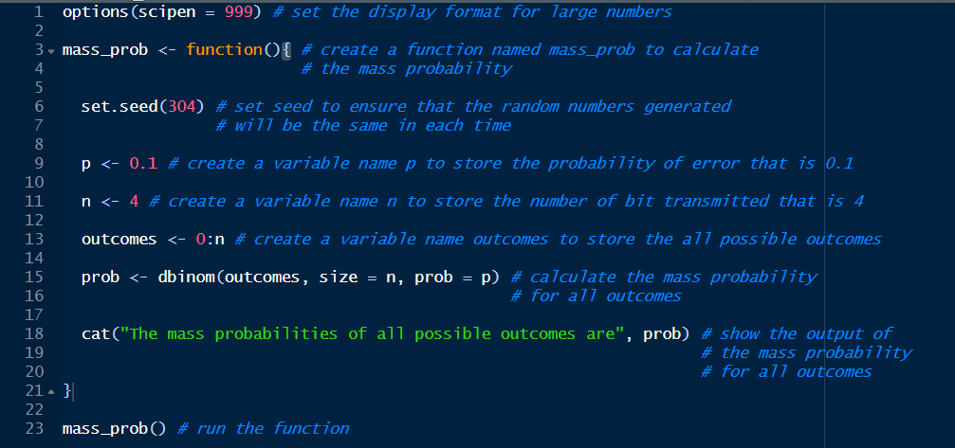**1. Mass Probability**

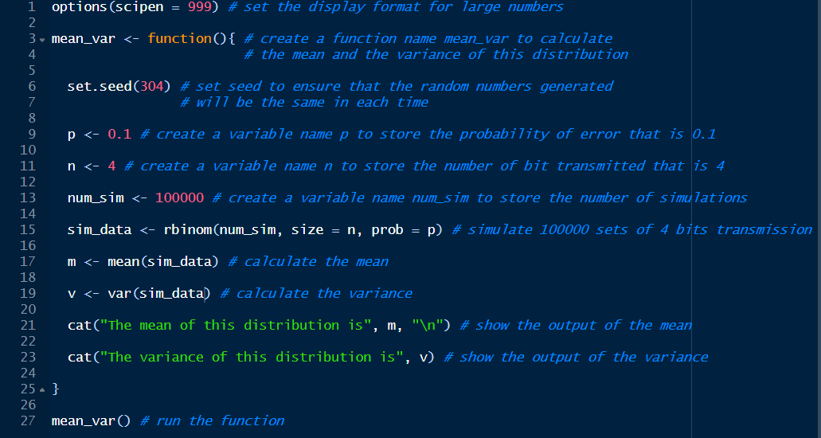**2. Mean and Variance**

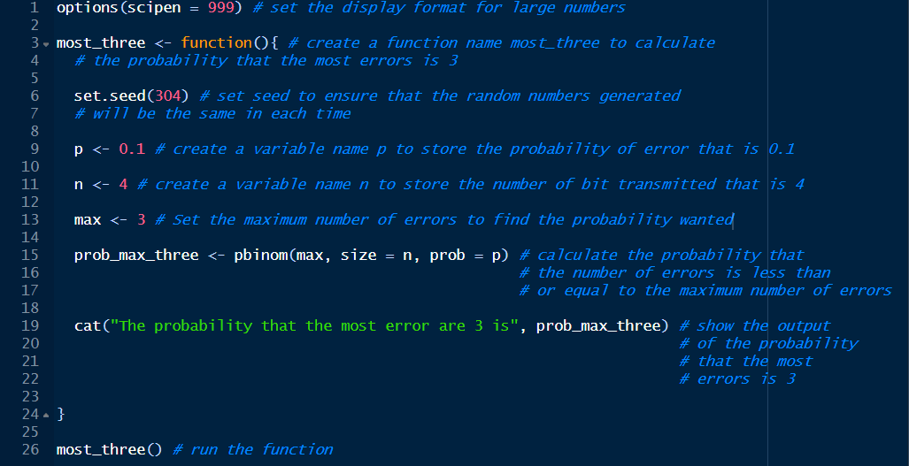**3. P(X =< 3)**

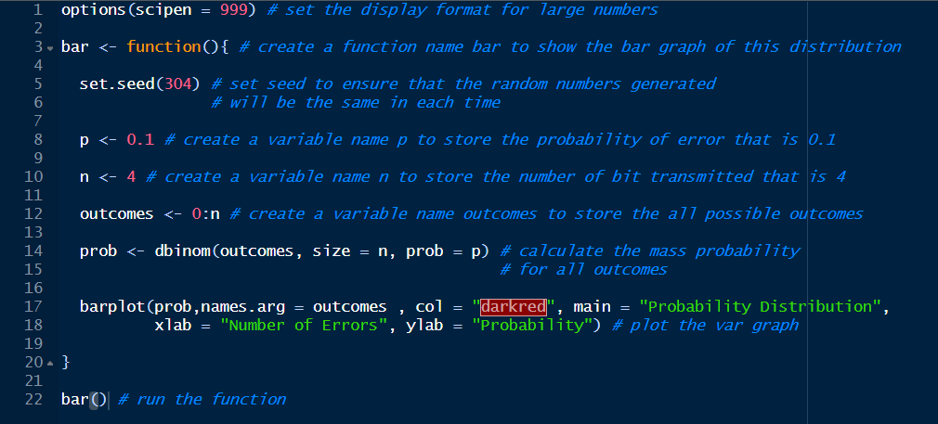**4. Bar Graph**

**Result:**

**1. Mass Probability**



**2. Mean and Variance**



**3. P(X =< 3)**



**4. Bar Graph**

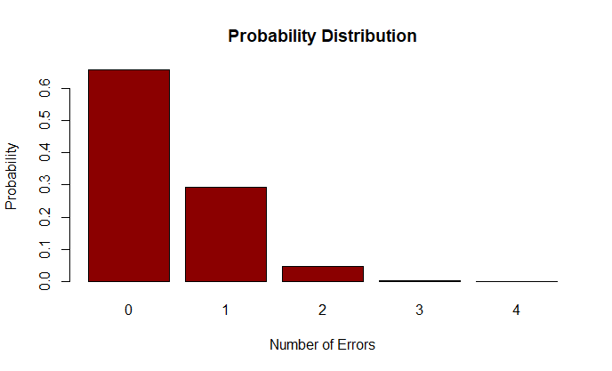

**Conclusion:**

From the experiment, the binomial distribution duplicates the probability of receiving a number of bit errors out of 4 transmitted bits, where the probability of error is 0.10. By calculating the probabilities, the outcome P(X = 0) is the most probable outcome because it receives all 4 bits without any errors. The probabilities decrease as the number of errors increases. This is expected as getting more errors becomes less and less likely. The outcome P(X = 4) is the least probable outcome because it is very unlikely to receive all 4 bits errors.